MAWLANA BHASHANI SCIENCE AND TECHNOLOGY UNIVERSITY
SANTOSH, TANGAIL-1902



DEPARTMENT OF INFORMATION AND COMMUNICATION TECHNOLOGY
Lab Report

Lab Report No : 02
Lab Report on : Design a Webpage containing some equations, marquee, audio, youtube video
as frame, pdf as frame, etc.
Course Title : Web Application Development Lab
Course Code : ICT-3204
Submitted By | Submitted To
Name: Kuldip Saha Mugdha  ID: IT-22018  3rd Year, 2nd Semester  Session: 2021-2022  Dept. of ICT, MBSTU | Mr. Md. Anowar Kabir  Lecturer  DEPARTMENT OF INFORMATION AND COMMUNICATION TECHNOLOGY  MAWLANA BHASHANI SCIENCE AND TECHNOLOGY UNIVERSITY

Date of Performance: 18/11/25 Date of Submission: 20/11/25
Introduction:
HTML is the standard language for creating webpages. Advanced HTML allows embedding multimedia elements, documents, and dynamic features that enhance user experience. In this lab, we design a webpage that includes:
• Mathematical equations
• Scrolling text (marquee)
• Audio playback
• YouTube video embedded as a frame
• PDF embedded as a frame
This exercise demonstrates practical usage of advanced HTML tags and multimedia embedding.

Objectives:
• To learn how to embed equations using HTML.
• To implement marquee for scrolling text.
• To add audio files to a webpage.
• To embed YouTube videos using .
• To embed PDF documents using .
• To design a functional, interactive webpage using advanced
HTML features.

Working Principle:
- Equations: Can be displayed using Unicode symbols, HTML entities, or Math.
2. Marquee: Creates scrolling text using the tag.
3. Audio: Embeds audio using the tag with controls.
4. YouTube Video as Frame: Embedded using with the YouTube embed url.
5. PDF as Frame: Embedded using pointing to the PDF file.

Equations: Can be displayed using Unicode symbols, HTML entities, or Math.
Code:
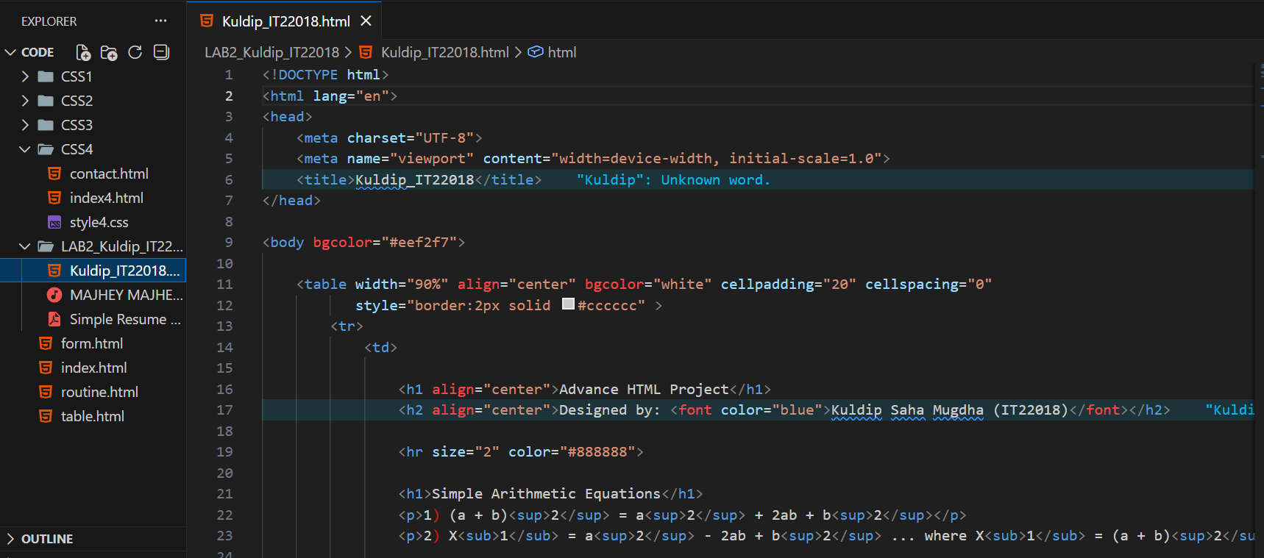
Output:
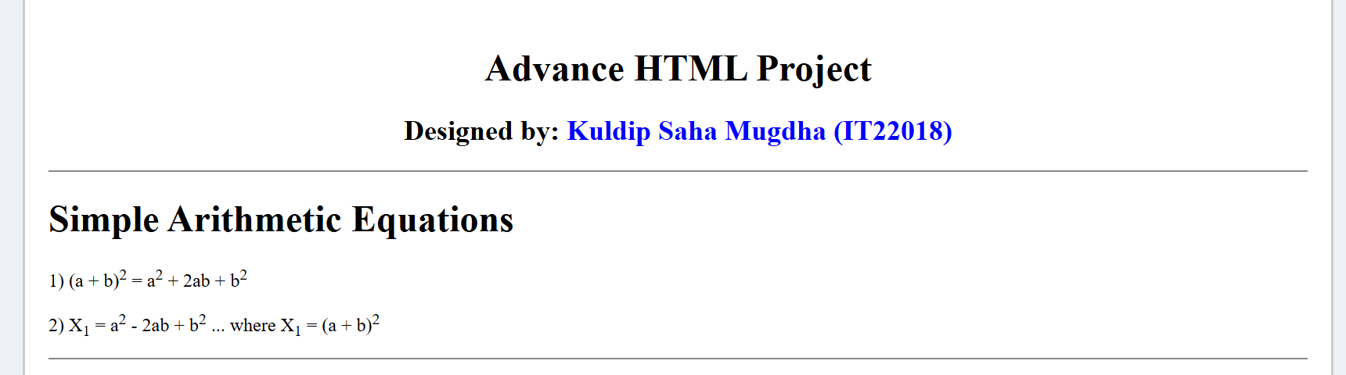

Marquee: Creates scrolling text using the tag.
Code:
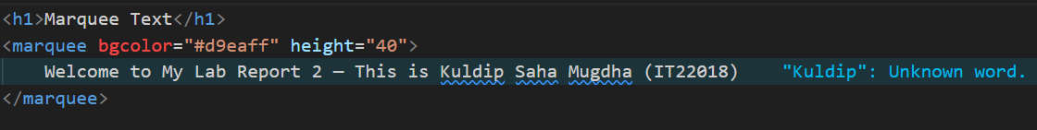
Output:
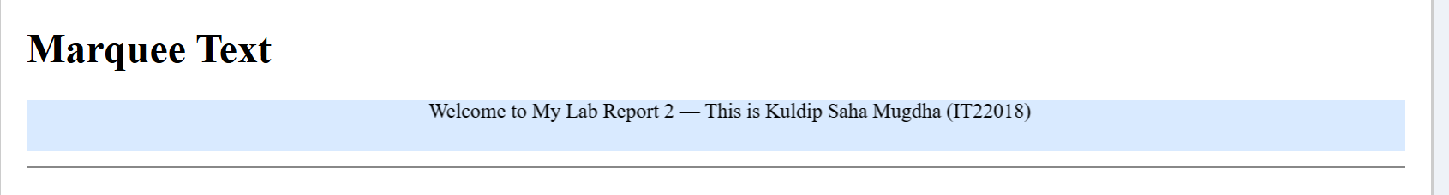
Audio: Embeds audio using the tag with controls.
Code:
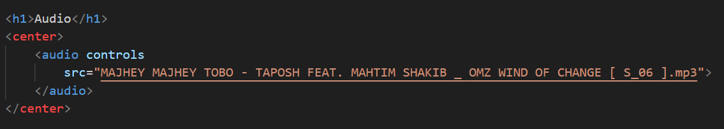
Output:
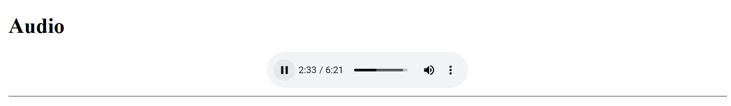

YouTube Video as Frame: Embedded using with the YouTube embed URL.
Code:
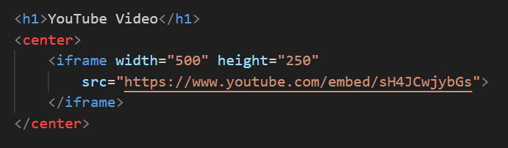
Output:
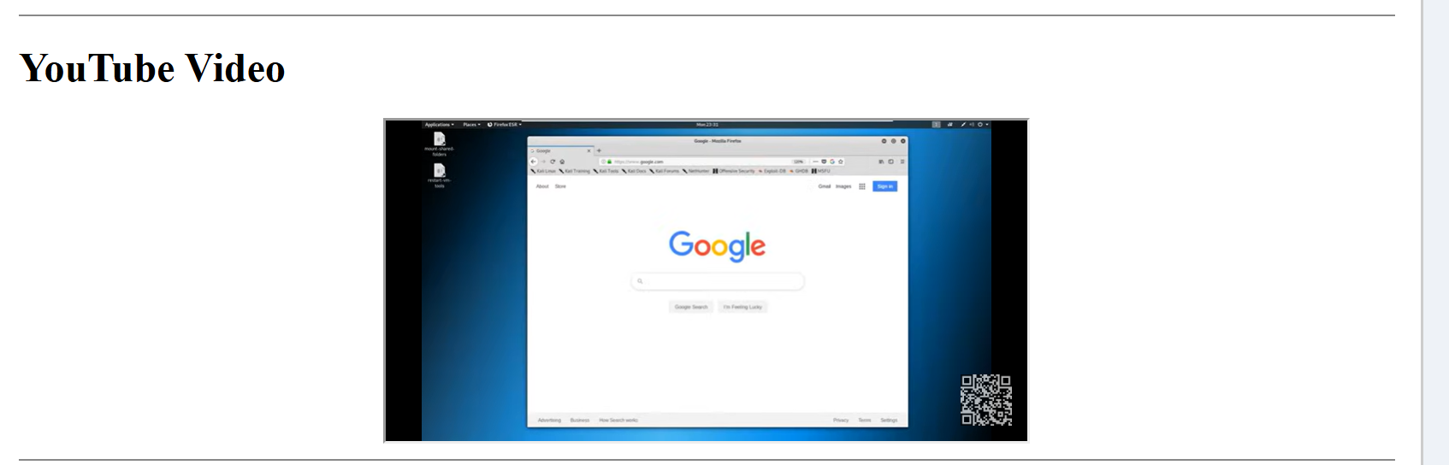

PDF as Frame: Embedded using pointing to the PDF file.
Code:
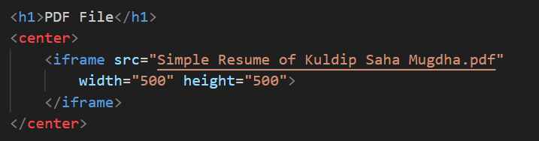
Output:
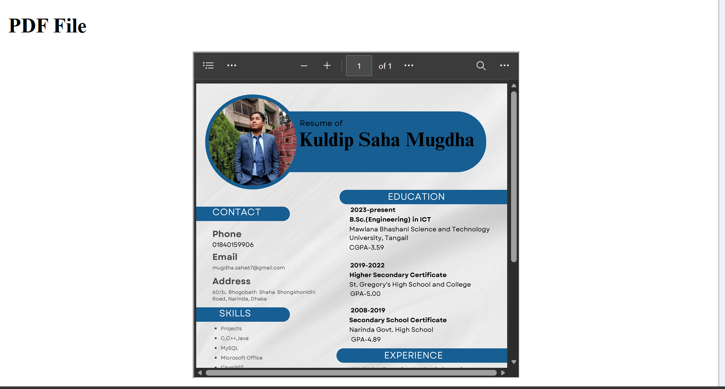
Conclusion:
In this lab, we successfully designed a webpage incorporating advanced HTML features. We learned how to:
• Embed equations for mathematical representation.
• Implement marquee for dynamic scrolling text.
• Include audio files with playback controls.
• Embed YouTube videos for interactive content.
• Display PDF documents directly in the webpage.

